Day 8

Class Exercise 1

@PostMapping("/person")

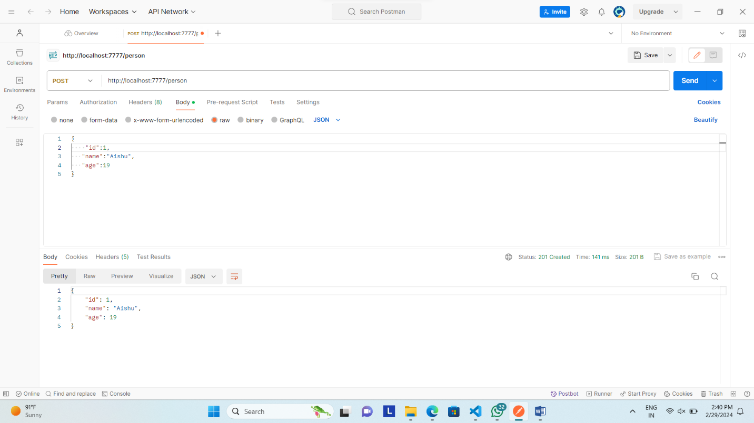

@GetMapping("/person/startsWithName/{value}")

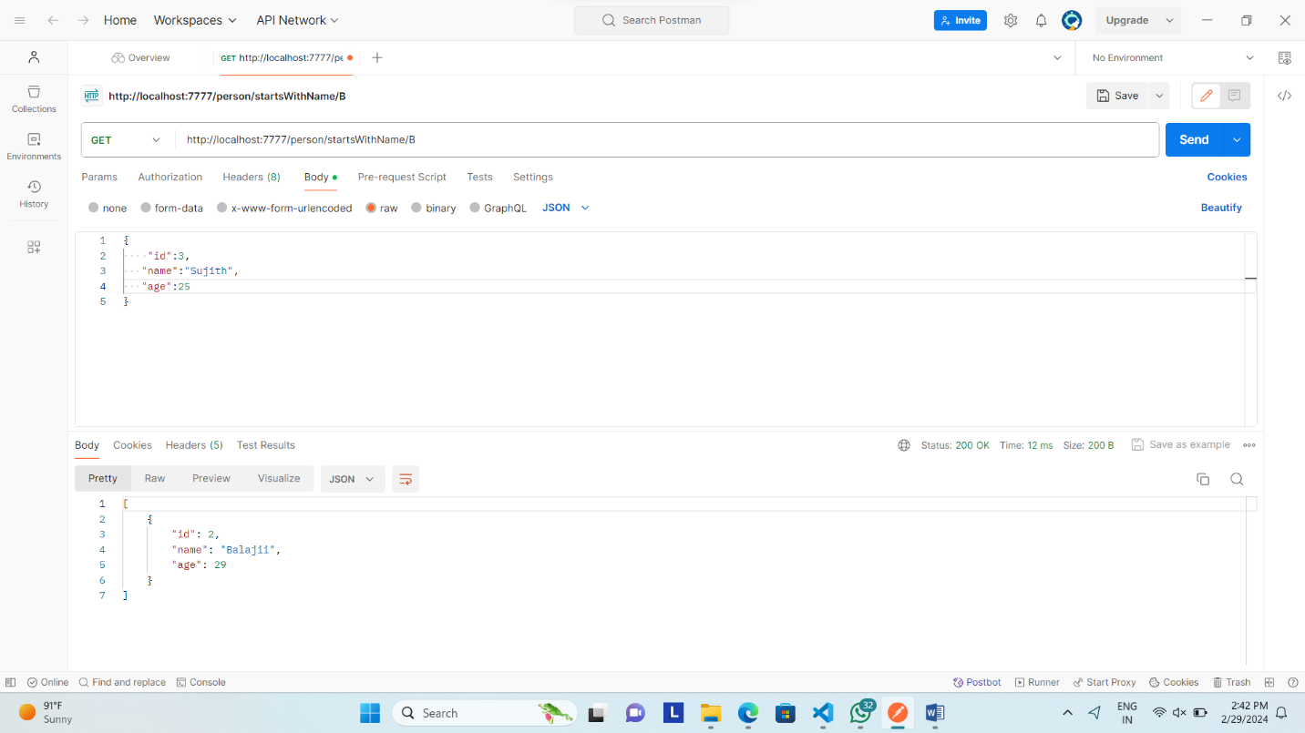

@GetMapping("/person/endsWithName/{value}")

